|  |  |
| --- | --- |
| Memo | |
|  | |
| to | **Loyens & Loeff community** |
| attn. |  |
| cc | Sebastian Chazhoor, Stichting Arun |
| from | Philippe Wijs / Tom Cramer |
| reference | 26112294-v1 (WIJR) |
| date | 12 December 2017 |

**You can build a school for the children of Arunachal Pradesh**

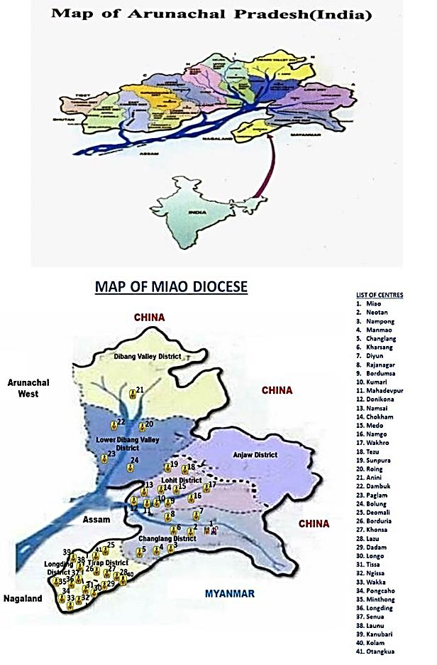**A brief Description of Arunachal Pradesh**

The state of Arunachal Pradesh is in the extreme North-East of India, bordering Buthan, China and Myanmar (Burma). The inhabitants vary ethnically from the rest of India and are largely Asian and Mongolian tribal people. The majority lives in scattered remote villages and small towns. The area is extremely isolated and underdeveloped with little modern infrastructure. There are more rivers than roads. Arunachal is simply a “forgotten” area that does not benefit from the development programmes undertaken by the Indian Government, This is where private initiative comes into play!

**The John Newman Educational Society**

The John Newman Educational Society is an Indian registered not-for-profit organisationresponsible for the development of the educational infrastructure in a large part of Arunachal Pradesh. It has a close relation with “Stichting Arun” in the Netherlands: [www.stichtingarun.nl](http://www.stichtingarun.nl)

**Summary of the educational infra structure**

The John Newman Educational Society was established in 2001 and is, as of today, running 46 schools with more than 16,000 children, aged 4 to 17 years.

The approach can be summarised as follows:

[next page]

* The public (state) schools in this remote area are dysfunctional (lack of teachers, no English education, schools closed for substantial periods of time, etc.). The Newman Society starts schools in areas where education is either lacking, of a very low quality, or reaching a low percentage of the children.
* The philosophy is to “kindle a flame”: always start by building a small school and staff it with trained professional teachers. If the school functions properly, a bigger school will be built and more teachers are recruited. The final step is the establishment of a high school.
* The schools are developed in close co-operation with the local communities. Parents pay school fees (in cash or produce, like rice and fruits) to make the schools self-supporting (exceptions are made for extremely poor families).
* Participation of the local community ensures that the school is the school of the village and not “the school of the Newman Society”. It is the community that sees it as the organization of the future of their children.
* The schools are open to children of all religions and ethnicity. Meals are offered to all children to ensure proper nutrition and health development of the children.
* A system of girl’s and boy’s hostels is developed. The aim is that every school will have a hostel for both boys and girls separately, since many of the children come from far away villages. Hence, the school also has to provide for the basic needs, safety and attention for these students in a boarding house.
* The Newman Society’s board and staff ascertain that the safety and well-being of the children is strictly adhered to with zero-tolerance in relation to the integrity of the children in every respect (“children first”).
* New schools typically start with around 50 children and will grow with one full class per year (between 30 to 50 children). The bigger established schools have around 800 to 900 students (most of the schools have waiting lists). Some schools dispose of a so-called “plus Two” department, offering higher education for talented youngsters in the age of 15 to 18, potentially allowing entrance to college / university.
* The local children and their parents are well aware of the riches of attending school and are eager to study. This eagerness, combined with generally sound intelligence, ensures an outstanding output.
* The policy is to educate local people as teachers, head masters, etc., to make the schools independent from outside help. This is a long term project.
* The best pupils having finished the “Plus Two” school are selected for a college education. These children should become future indigenous leaders of the Arunachal society. Some of the early Newman school pupils are now on their way to high ranking government officials, head masters, etc.. As a result, the state government is becoming much more positive towards the efforts of the Newman Society.
* The quality and high spirit of the teachers is of key importance. This is why a vocational training centre was set-up, where training programs are developed for teachers. This will also be an important meeting place for all stakeholders that work in the Newman schools.
* 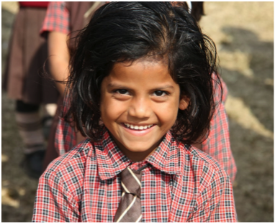In August 2014, the first College in the region, offering a Bachelor Degree, opened its doors. The college means that not all students need to go to faraway places to study.

**New schools / extension of schools**

The above educational efforts and developments require - apart from the recruitment and training of staff (teachers, head masters, etc.) - a substantial program to erect new school buildings and extent existing school buildings.

The schools are initially housed in temporary buildings (bamboo sheds). Once a school reaches an appropriate size, the temporary constructions, *funding permitting*, is replaced by a solid concrete building. The Newman Society has its own team for the planning, procurement and logistics in connection with the building of schools. The logistics of getting the building material from Assam to the remote construction sites is one of the biggest challenges and unfortunate cost driver.

The construction costs are kept to a minimum by using a standard design for all school buildings. All concrete school buildings are basic constructions requiring limited maintenance. All maintenance costs are part of the school’s budget that is being financed locally (school fees, etc.).

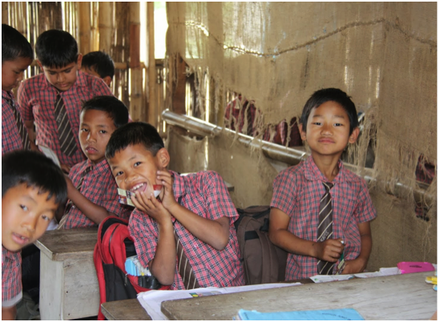It is the intention that in the next five years, the existing schools will be further developed (more class rooms and other facilities), new schools will be opened and that the number of students will grow from 17,000 to 26,000.

The Newman Society has existing fast growing schools that urgently require new buildings to cope with the increasing number of students and in addition has encouraging requests from a number of communities that lack (decent) education to start new schools.

**Newman School in Neotan**

Recently, Philippe Wijs and Tom Cramer stayed a couple of months in the Newman school in Neotan to teach English, history, maths and science (English curriculum) to the local students. During their stay they also visited various other schools in the region (several hours driving!). The Newman is not connected to a town but rather a village and the surrounding region. The number of students is currently approx. 400.

Specifically, this school would benefit from the development of a ‘refectory building’. Tom and Philippe were shocked to see the current run down bamboo construction that serves as refectory. The construction does not offer the boys and girls any hygiene or insulation. Completely open on one side and with a very poor roof, this damp place is freezing during winters when temperatures drop below 10 degrees.

However, only building a concrete refectory room with storage facilities, etc. would not be the most suitable option. As Tom and Philippe talked with the school principal and other stakeholders involved, they started to more and more realise the importance but above all the potential of this project. Below is a building plan to change this building into a concrete one with two floors; ground and first floor.

The ground floor would not only consist of a very basic but clean and proper eating hall, but also of a small refectory for teachers, bed rooms for the staff and storage facilities. The first floor will serve as the conference and common hall of the school (gatherings of all children, performances, conferences, exams, etc.).

Currently, teachers are occupying what once were the library and science lab of the school. Erecting the new building would not only create decent eating, gathering and staff facilities for the school, but will also create and free the space that will allow the school to have the required infrastructure to increase the admissions to the “plus two years” programme. This programme will offer 15 to 18 year old boys and girls the full education up to college level! It would allow many of the current students to stay until including the final year of high school, after which they would have a much higher chance of getting a job or even enter college. Many 14 / 15 years old students expressed to Tom and Philippe their wish to continue for another two years, as they are foreseeing a bleach future if they were to leave school at the age of 15 with little hope of finding a job. This new building will help the school to grow from approx. 400 to 600 students (which will take a couple of years).

See annex 1 and 2 for a budget and the drawings for the new building. The total estimated costs are approx. EUR 94,000 (71 Lakhs). The board of Stichting Arun is in the process of reviewing the budget provided by the Newman Society and will likely obtain a downwards adjustment of the overall costs to an estimated EUR 87,000. Costs are benchmarked with similar past projects.

We think that this specific project would be a very wise investment, as one additional building can change the lives of scores of students! The financial contribution of the Loyens & Loeff community can help the children in an immense way in shaping their future and making them more aware of their role in society.

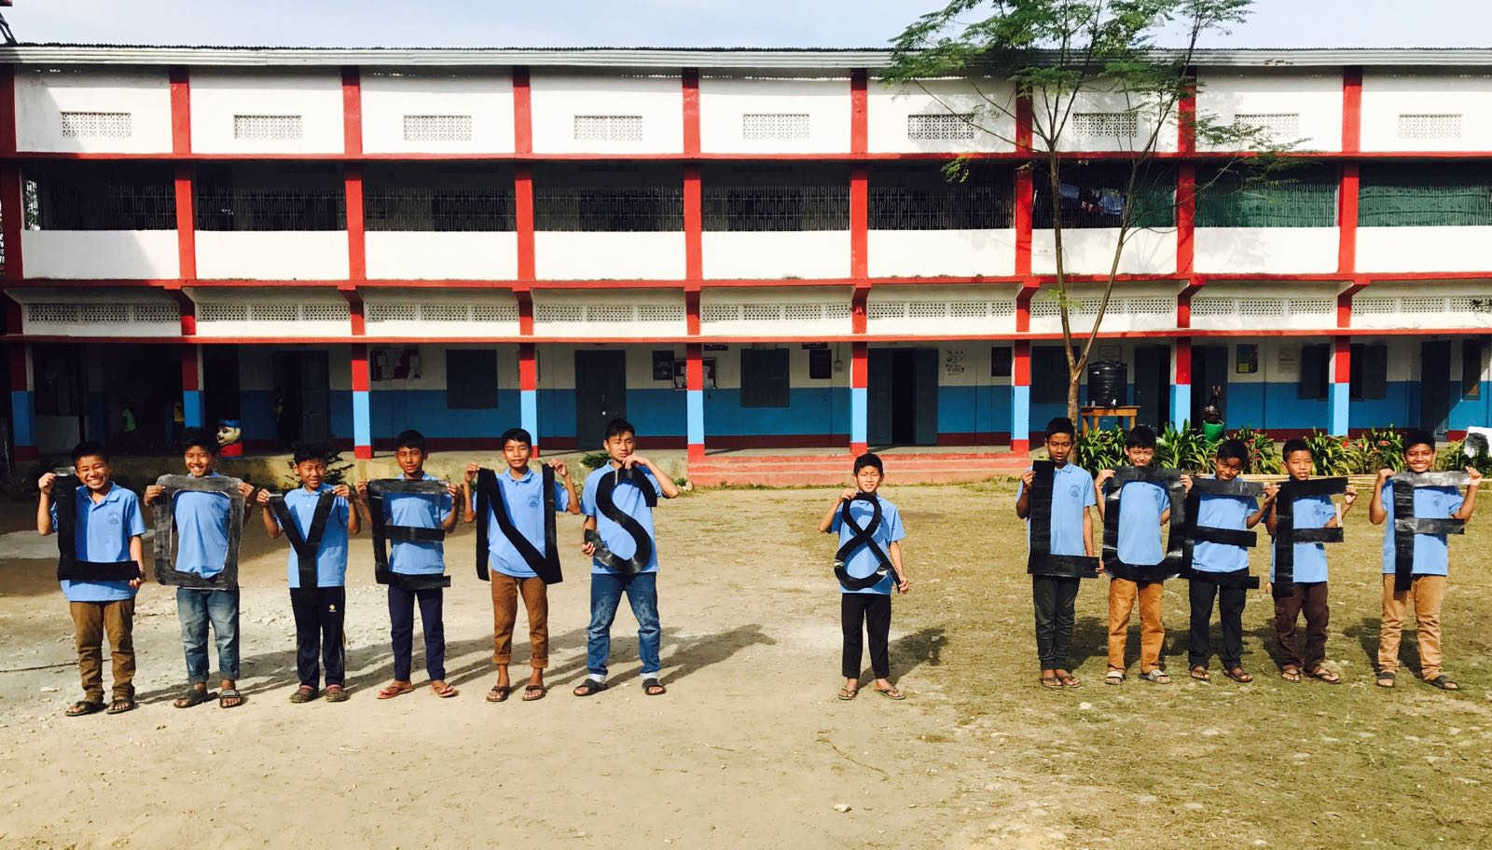

*The kids sourced graphite from the woods to make a black paint and create the letters “LOYENS & LOEFF”.*

Please do not hesitate to contact us if you need any further information.

Philippe Wijs / Tom Cramer: +31623734899

**Annex 1: Preliminary budget for new building Newman School**

**ESTIMATE OF REFECTORY CUM MULTIPURPOSE HALL FOR NEWTON SCHOOL AT Neotan , AP**

Ground Floor Area:2960.45 SFT

First Floor Area : 2960.45 SFT

Cost of construction:

Ground Floor: 2960.45 SFT @ Rs 1200.00 per sft Rs 35,52,540.00

First Floor: 2960.45 SFT @ Rs 1000.00 per sft Rs 29,60,450.00

TOTAL Rs 65,12,990.00

Add

8% for electrification on civil cost Rs 5, 21,039.00

1% for firefighting on civil cost Rs 65,130.00

TOTAL Rs 70,99,159.00

Rounded off: seventy one Lakhs. Estimate is based on present market rate and inclusive of all labour, material and transportation costs.

**BRIEF SPECIFICATION**:

1. Foundation : R.C.C spread footing as per design.
2. Columns and beams : R.C.C as per design.
3. Plinth wall : 230 thick brick wall in cement mortar.
4. Floor : I.P.S Wall
5. : Full brick / half brick wall with cement plastering.
6. Roof : C.G.I sheet roofing.
7. Door : Flush door multiwyn steel frame.
8. Window / Ventilator : Glazed window & ventilator in multiwyn steel frame.
9. Miscellaneous : Toilet floors with ceramic tiles and wall with glazed tiles finish.
10. Plinth Height : 2'-0"
11. Height of the building : 11'-0"
12. Colour scheme : Wall putty on cement plaster and washable distemper in

interior and snow-cem on exterior wall.

**Annex 2: Drawings of new building**

